Assignment 1:-

Filename:-Assign1.java

Output(the count in your execution can be different, since its based on random number):-

frequency of heads:490

frequency of tails:510

Snapshot:

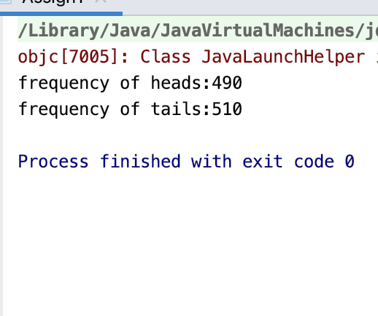

Assignment2

Filename: Assign2.java

Ouput:-

Press enter to stop the thread

message printed..

message printed..

message printed..

Snapshot:-

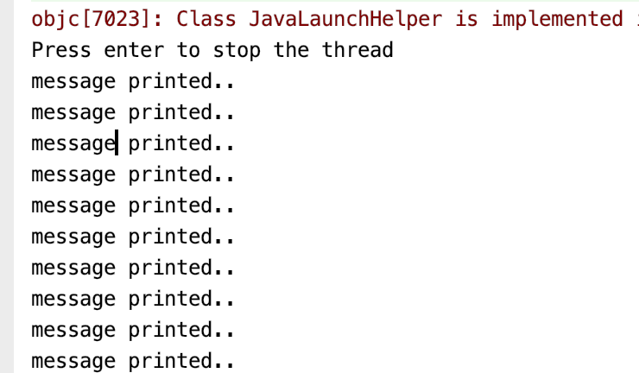

Assignment 3:

*Question 3 ( 5 % ) Write a program that employs 2 threads that each toss their  
 own die (modelled by a random number generator that generates random numbers in the  
 range 1..6) a given number of times. In both cases the result of each toss is stored in a shared array.  
 The array is deemed to be large enough to store the result of every throw and each thread should only  
 write to its own array segment. Once the threads have completed their work then the main program  
 counts the frequency of each number thrown and prints it on the screen.*

Filename:Assign3.java

Output:-

The frequency of each number for dice 1 is as follows:

one:0

two:2

three:3

four:1

five:3

six:1

The frequency of each number for dice 2 is as follows:

one:2

two:1

three:1

four:3

five:1

six:2

snapshot of the output:-

